## Denotation

1. Uniform/Flip noise:
   1. uniform: when corruption_prob = 0.2, 20% of one class is randomly assigned to all 10 classes, in other words, 0.82 are left for each class;
   2. flip: when corruption_prob = 0.2, 20% of one class is fliped to another class, 0.8 are left for each class
2. uncertainty statistics:
   1. entropy: entropy of averaged softmax prob output(from T MC sampling of the network parameter)
   2. variance: the average of variance of each logit(variance of MC samples)
   3. pred_a: average of the predicted sigma of logits(or just predict one sigma for all logits), a means aleatoric uncertainty here
   4. var_ratio: variational ratio, the total of the probability of the classes except of the class with the largest probability
3. heteroscedastic loss: see in [Kendall et al.](https://arxiv.org/abs/1703.04977), heteroscedastic aleatoric uncertainty loss
4. hs or heteroscedastic single: heteroscedastic loss; s or simple: softmax entropy loss
5. reweight_norm: after we achieve the weight of samples in a minibatch, we apply different normalization methods to the weights
   1. sig_m: we apply a sigmoid-like function and normalize the weights to (0,1), specifically, f=(sigmoid*2-1)/batch_size, this maps (0,+inf) to (0,1/batch_size)
   2. none: none normalization
   3. batch_norm: ensure that the total weight of a minibatch is the same(if a minibatch has fewer samples(last of an epoch) than we reduce the sum of weight in proportion
6. ratio_x%weight, ratio_x%loss, ratio_x%uncer: the ratio of corrupted sample in the x% sample with smallest weight or largest loss or largest uncertainty

## Loss related reweighting

1. Meta-Weight-Net: Learning an Explicit Mapping For Sample Weighting (2019 NIPS)

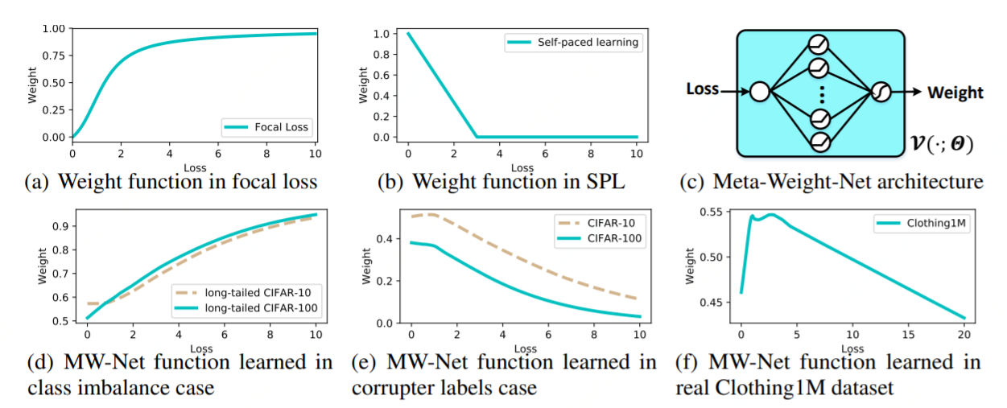

* 1. insight：用单隐藏层MLP网络来拟合loss-weight函数每个batch依次更新MLP参数（基于现有的MLP参数也就是权重函数得到更新过的分类器参数，这个参数在metadata的表现对MLP参数求梯度），分类器参数（用更新过的MLP参数更新分类器参数）
  2. 噪音甄别：weight仅和loss相关weight=f(loss)，但weight与loss不一定是单调关系，可以用ratio_x%weight来测量
  3. 数据集：CIFAR10/100, clothing1M
  4. 噪音类型： uniform noise, flip noise, imbalanced dataset
  5. 模型训练：[具体内容](https://cf.jd.com/pages/viewpage.action?pageId=272567405)

1. Unsupervised Label Noise Modeling and Loss Correction (2019 ICML)

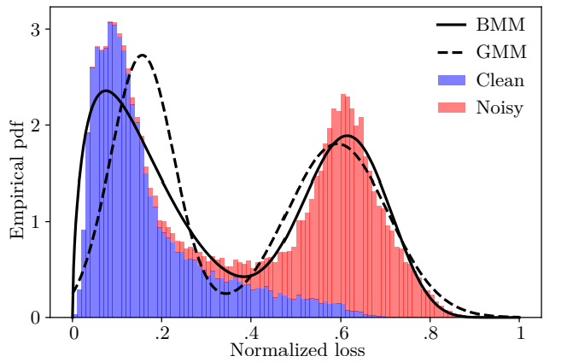

* 1. insight：与meta-weight-net同为loss correlated weight，将loss的分布建模为BMM（beta mixture model），然后将某个sample的loss代入到BMM中得到属于噪声的概率，将这个概率应用到static bootstrapping loss中（将样本loss中w_i变为动态的）从而影响样本权重；对数据增强方式mixup有专门优化
  2. 噪音甄别：weight仅与loss单调负相关，可以用ratio_x%weight或ratio_x%loss测量
  3. 数据集：CIFAR10/100，TinyImageNet，Clothing1M
  4. 噪音类型： uniform noise
  5. 模型训练：[具体内容](https://cf.jd.com/pages/viewpage.action?pageId=272567405)

1. Using Trusted Data to Train Deep Networks on Labels Corrupted by Severe Noise (2018 NIPS)

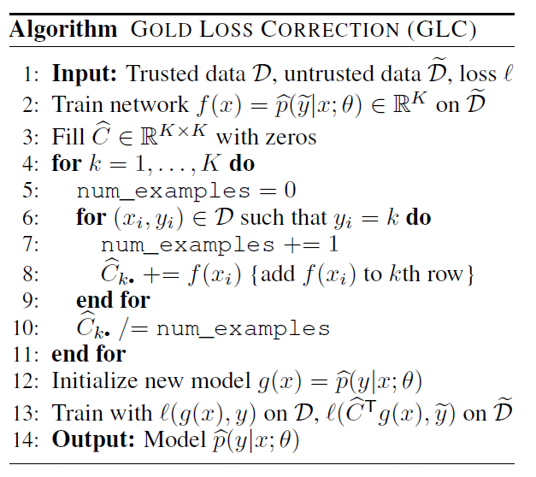

* 1. Insight：Use clean set to estimate corruption matrix, under the assumption of the number of trusted samples in each class, and conditional independence of y and y_tilda(clean and corrupted) given x. Then train on the corrected output(applying the corruption matrix on softmax output).
  2. 噪音甄别：不是通过权重来识别噪音，不需要噪音甄别，而是通过直接把结果经过转化矩阵再计算loss
  3. 数据集：MNIST, CIFAR10/100, IMDB, Twitter, SST
  4. 噪音类型： uniform noise, flip noise, Hierarchical Corruption(apply uniform corruption only to semantically similar classes)
  5. 模型训练：[具体内容](https://cf.jd.com/pages/viewpage.action?pageId=272567405)

1. Making Deep Neural Networks Robust to Label Noise: a Loss Correction Approach (2017 CVPR)

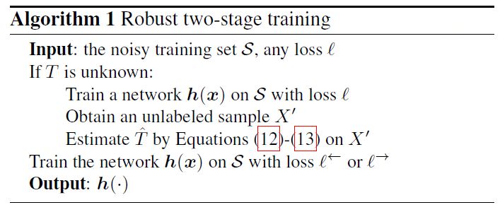

* 1. Insight：estimate each component of matrix T just based on noisy class probability estimates(no need for clean validation set) by training on the noisy set. Then apply loss correction forward or backward.
  2. 噪音甄别：同上
  3. 数据集：MNIST, CIFAR10/100, IMDB, Clothing1M
  4. 噪音类型： uniform noise(symmetric noise), and self defined flip noise
  5. 模型训练：[具体内容](https://cf.jd.com/pages/viewpage.action?pageId=272567405)

## Meta learning

1. Meta-Weight-Net: Learning an Explicit Mapping For Sample Weighting (2019 NIPS): see the above section
2. Learning to Reweight Examples for Robust Deep Learning (2018 ICML)

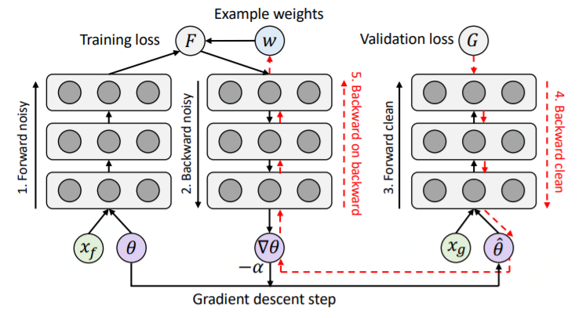

* 1. Insight：每一个noisy batch先前传，对网络参数后传，此时网络参数实际上是不更新的，但是计算图里面是由eps（0，所以不更新）和数据权重的乘积，用这个参数在干净的val set中前传，就能数据权重后传eps为0时候数据权重的梯度更新权重，之后再在noisy batch中先前传再后传（按照更新过的权重eps）
  2. 噪音甄别：weight与metadata中的validation loss，神经网络两部分的参数都有复杂关系，噪音甄别能力可以用ratio_x%weight测量
  3. 数据集：MNIST, CIFAR10/100
  4. 噪音类型： uniform noise(UNIFORM FLIP), and BACKGROUND FLIP(all classes are flipped to a background class, which is a combination of noisy dataset and imbalanced dataset)
  5. 模型训练：[具体内容](https://cf.jd.com/pages/viewpage.action?pageId=272567405)

## Uncertainty related reweighting

1. Uncertainty Based Detection and Relabeling of Noisy Image Labels (2019)

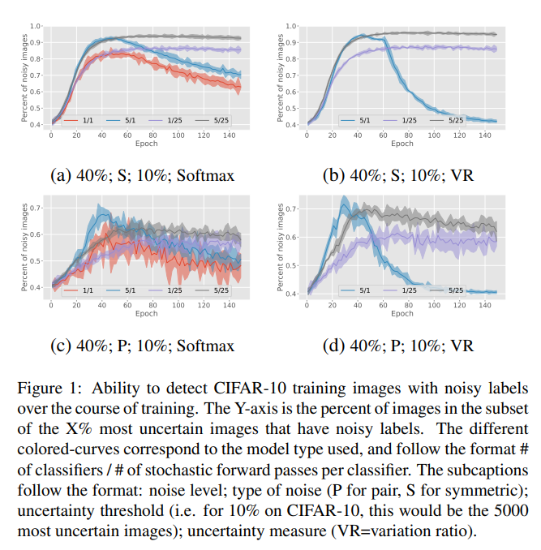

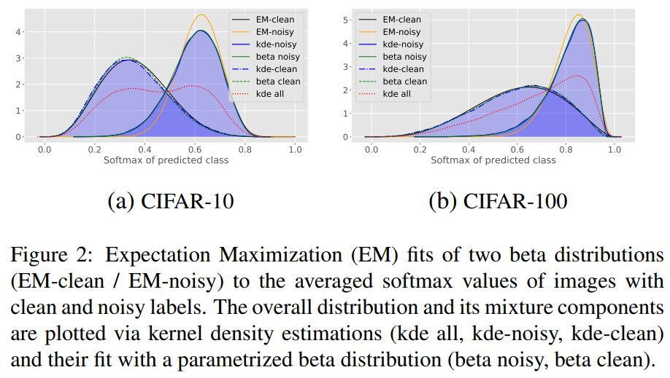

* 1. Insight：用MCdropout与deep ensemble结合得到的参数分布来采样得到预测值分布，在这个分布上计算variational ratio，BALD，或softmax maximum等统计量找到noisy label（不确定的）。用前面epoch还没有过拟合的模型来relabel判断为noisy label的样本，这个具体选取的epoch数由一个heuristic的方法得到
  2. 噪音甄别：不属于reweighting范畴，每次选出前x%不确定性最大的数据来重新分配标签，噪音甄别能力可以用ratio_x%uncer测量。
  3. 数据集：CIFAR10/100
  4. 噪音类型： uniform noise
  5. 模型训练：[具体内容](https://cf.jd.com/pages/viewpage.action?pageId=272567405)

1. Deep Bayesian self training (2019)
   1. Insight：预测每个样本的伪标签，并得到这个伪标签的不确定性（这里的是du+mu），它认为不管是du大还是mu大，都是网络对伪标签不确定，所以权重都要减。权重直接为这个总不确定性的倒数再乘上一个随iteration衰减的函数
   2. 噪音甄别：属于自训练，不存在噪声问题
   3. 数据集：MNIST, self-provided real dataset
   4. 噪音类型：情景不同，为self-training过程
   5. 模型训练：[具体内容](https://cf.jd.com/pages/viewpage.action?pageId=272567405)